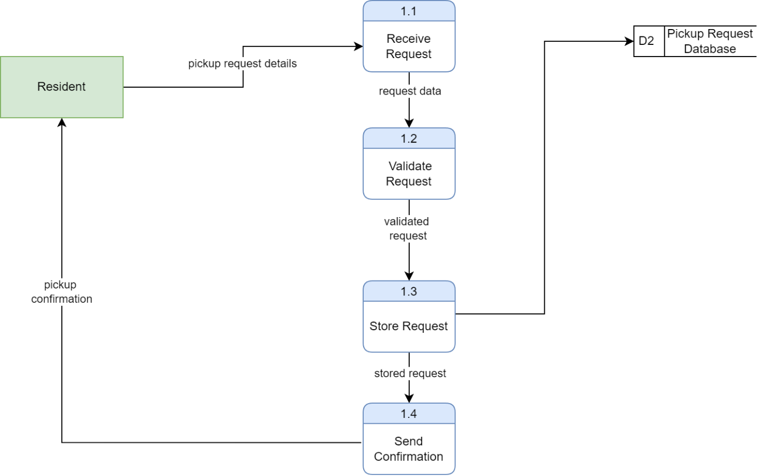
The DFD Level 1 diagram gives a breakdown of the process of “Manage Pickup Request” that was given in Level 0 diagram. It demonstrates the process of the system that a pickup request goes through, including the process of receiving the request and dispatching confirmation to the resident. This starts with pickup request information being submitted by the Resident into the system. These are initially processed by 1.1 Receive Request in which the system receives and prepares the request data to be processed further. Then the request is sent to 1.2 Validate Request where the system verifies the request is valid, complete, and satisfies the specifications of the request. Once a request is validated, a validated request is created. The validated request is then submitted to 1.3 Store Request whereby the system stores the request in the D2 Pickup Request Database. This will make sure that the request is duly recorded and can be utilized to schedule and process it further. Once the request has been stored, the system moves to 1.4 Send Confirmation in which a pickup confirmation message is created and sent back to the resident. This is to ensure that the request has been received and processed successfully. All in all, this Level 1 diagram shows a clear picture of how the system receives user input by going through a series of internal processes, which ensures that pickup requests are verified, stored, and approved effectively.

